Kubernetes Task

Task Description:
Setup minikube at your local and explore creating namespaces (Go through official documentation).
Steps:
1. Install Minikube and kubectl:
Command for minikube is choco install minikube -y
[ Note if getting any error while executing this command then run the below command to install minikube]

Set-ExecutionPolicy Bypass -Scope Process -Force; `
[System.Net.ServicePointManager]::SecurityProtocol = [System.Net.ServicePointManager]::SecurityProtocol -bor 3072; `
iex ((New-Object System.Net.WebClient).DownloadString('https://community.c

Below command to check minikube version and choco version:
minikube version
choco version
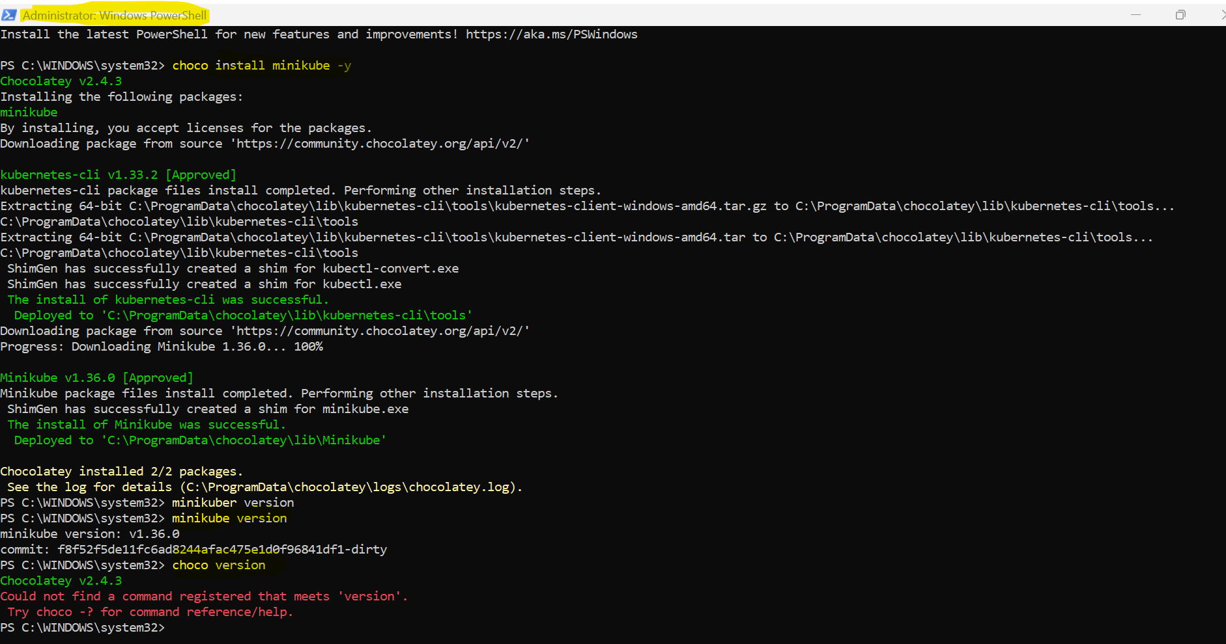

Command for install kubectl is choco install kubernetes-cli -y

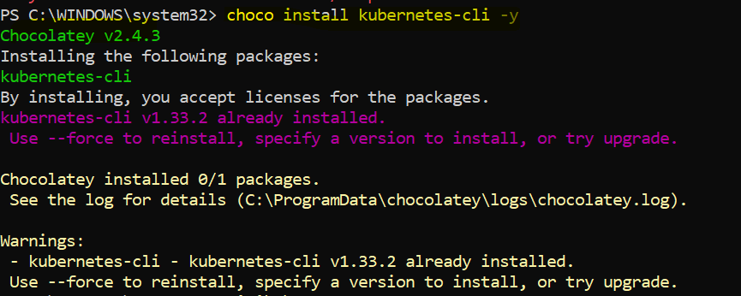

2. Start Minikube:
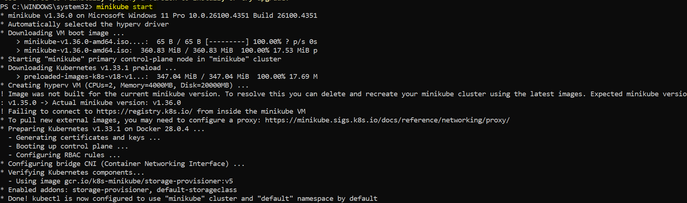

3. Verify Minikube Status:
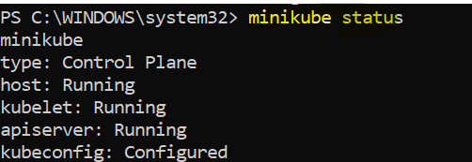

4. Create a Namespace:
Command to create a new namespace is kubectl create namespace <namespace_name>
For example: kubectl create namespace test

5. List Namespaces:
Use kubectl get namespaces to see all existing namespaces, including the one you just created.
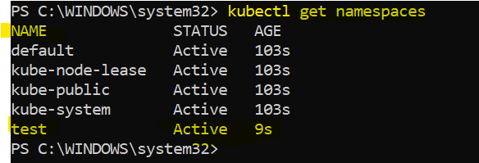

6. Delete a Namespace:
Use kubectl delete namespace <namespace_name> to remove a namespace.
For example: kubectl delete namespace test
